Kindergarten Science: Plant Needs
January 28-February 1, 2019
Standards:  K-LS1-1: Use observations to describe patterns of what plants and animals (including humans) need to survive. |  |  |  | Essential Question:  How are plants affected by the environment?
 | Monday (1.14) | Tuesday (1.15) | Wednesday (1.16) |  | Thursday (1.17) | Friday (1.18)
Learning Target | I can describe things as living or non-living. | I can explain the parts of a plant. | I can conduct an experiment to learn how plants are affected by their environment. |  | I can. Explain what a plant needs to grow. | I can explain that plants make their own food.
Science Lessons | Little Science Thinkers Unit 4 Lesson 1  Set the purpose for the lesson by introducing the Learning Target.  Display Guiding Question: How can we tell if something is living or non-living?  Investigation:  * Students will look at photographs and discuss if the things are living or nonliving and why, answering the question: What makes it living or nonliving?  * List student responses to Guiding Question: How can we tell if something is living or non-living? on Post-It notes. Stick them to the Guiding Question chart paper. List each response once.  •Recap all of the reasons why they think something is living or nonliving.  •Read the text, Is It Alive, (display on ActiveBoard) then revisit the Guiding Question.  •Students will review living things pictures again and see if they meet all of the criteria of living things. Ex: Plant- Does it move? Does it grow? Does it change? Reproduce? Etc.  •Students can help to create a separate anchor chart that lists qualities of living things.  * Students will complete Activity Sheet 4.1 | Little Science Thinkers Unit 4 Lesson 2  Set the purpose for the lesson by introducing the Learning Target.  Display Guiding Question: What Are the Parts of a Plant? on chart paper/dry erase board and ask students to share ideas.  * Read and discuss Plant Parts (display on ActiveBoard)  Plant Diagramming:  Teacher Prep:  Draw a picture of a large plant on a piece of chart paper. Spread picture pieces around the floor face up.  * Students will choose the correct plant part and place it on the diagram after listening to the clues the teacher reads.  Plant Dissection:  * Students will use magnifying glasses to take a closer look at each part of a plant, naming each part of a plant.  * Students will carefully remove that part (ex: take the flower off the plant) and place it in the bowl.  * Students will pass the bowl around the circle with the magnifying glass and make observations.  • Students will complete Activity Sheet 4.2 | Little Science Thinkers Unit 4 Lesson 3  Set the purpose for the lesson by introducing the Learning Target.  *Display anchor chart “What Do Scientists Do?”  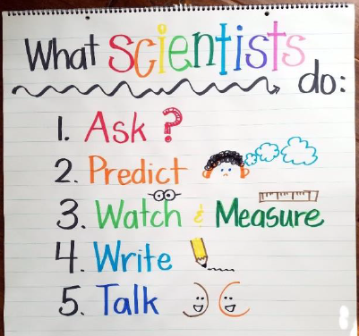  * Discuss what scientists do: Scientists ask questions and today we are going to do an experiment to answer the question: How does the environment affect how a seed grows?  * Show anchor chart listing the different environments: no sun, no water, paper towel, soil, rocks, and sand and explain what each means. 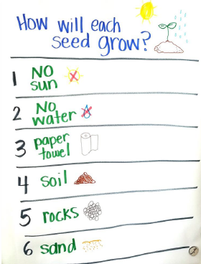  * Students will put paper towels, soil, sand, and rocks into labeled sandwich bags, lay them flat on the table, and place 2-3 seeds in each bag so that they are visible.  * Students will identify which bags will get water and sun and which will not. Students will spray water into the bags that get water and decide where to put the bags that do not get sunlight.  * Students will write down their predictions about how they think the seeds will grow in their experiment booklet.  * Students will complete Activity Sheet 4.3  Over the next few weeks, students will observe and record their observations in their booklet. |  | Little Science Thinkers Unit 4 Lesson 4  Set the purpose for the lesson by introducing the Learning Target.  Display Guiding Question: What does a plant need to grow? on chart paper/dry erase board and ask students to share ideas.  * Read What Plants Need (display on ActiveBoard)  * Students will read discussion questions and discuss whether or not they think the plant will grow and why.  * Students will read each page of their What Plants Need mini-books.  * Students will draw to show how the plant can receive what it needs.  * Students will complete Acivity Page 4.4 | Little Science Thinkers Unit 4 Lesson 5  Set the purpose for the lesson by introducing the Learning Target.  Display Guiding Question: How do plants get food? on chart paper/dry erase board and ask students to share ideas.  * Read How Plants Get Food (display on ActiveBoard)  * Students will help to make an anchor chart to show what plants need to make food.  * Students will observe their seeds and record observations in their booklet by circling the stage that best matches what the seed in each environment looks like.  * Students will complete Activity Page 4.5

