Social Studies/Science

November 12-16, 2018

Science Standards and Focus Skills:
Science:  K-LS1-1. Use observations to describe patterns of what plants and animals (including humans) need to survive | Focus Skill:  - Identify the parts of a pumpkin.  - Sequence the life cycle of a pumpkin.
Social Studies Standards and Focus Skills:
Social Studies:  K.2.1 Compare and contrast children and families of today with those in the past using various sources  K.2.2 Identify symbols of local, state, and national importance using various sources  K.2.3 Identify local, state, and national celebrations, holidays, and events using various sources  K.2.4 Recall facts about people of the past and present | Focus Skill:  - Explain who the Pilgrims were and why they came to America.  - Explain who the Native Americans were and how they lived.  - Explain the events of the first Thanksgiving and how we celebrate Thanksgiving today.  Essential Question: Who were the Pilgrims and Native Americans and why were they important?

Monday (11.12) | Tuesday (11.13) | Wednesday (11.14) | Thursday (11.15) | Friday (11.16)
Social Studies Lesson | Social Studies | Social Studies Lesson | Social Studies Lesson | Science Lesson
Learning Target: I can explain who the Pilgrims were and why they came to America. | Learning Target: I can explain who the Native Americans were and how they lived. | Learning Target: I can explain the events of the first Thanksgiving. | Learning Target: I can explain how and why people celebrate Thanksgiving today. | Learning Target: I can identify the parts of a pumpkin and sequence the life cycle of a pumpkin.
Little Social Studies Thinkers Pilgrims and Native American Mini-Unit Lesson 2:  *Students will listen to the teacher read The Story of the Pilgrims by Katherine Ross  * Students will play the This or That game and vote on which statements are true or false about the Pilgrims.  * Students will complete activity page 2  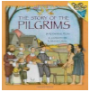 | Little Social Studies Thinkers Pilgrims and Native American Mini-Unit Lesson 3:  * Students will listen to the teacher read The Wampanoag by Karen Jones (display on Active Board)  * Students will help to create a fact and opinion anchor chart about the Wampanoag. Students will pull a card from a paper bag or basket and decide if the statement is a fact that can be proven or an opinion that shares someone’s feelings.  * Students will complete activity page 3  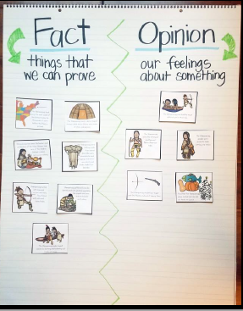 | Little Social Studies Thinkers Pilgrims and Native American Mini-Unit Lesson 4:  *Students will listen to the teacher read stories about the first Thanksgiving. (Teacher’s choice)  *Students will help to make a “Wanted” anchor chart with facts about the first Thanksgiving. Students will choose cards and decide which category it belongs in. (who, where, when, how long, what, and why)  * Students will complete activity page 4  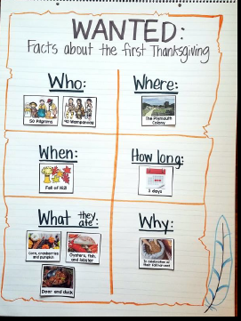 | Little Social Studies Thinkers Pilgrims and Native American Mini-Unit Lesson 5:  *Students will review the anchor chart from yesterday’s lesson to discuss how and why the first Thanksgiving was celebrated.  *Students will discuss how and why they celebrate Thanksgiving today and what they are thankful for.  * Students will make a turkey craft and write about what they are thankful for.  *Students will create a book about the First Thanksgiving, using a brown paper bag, and draw an illustration to match the text for each page.  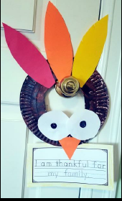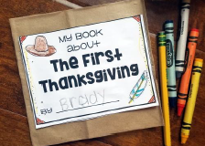 | * Students will listen to Pumpkin (See it Grow) by Jackie Lee on Epic!  * Students will sequence the lifecycle of a pumpkin with picture cards and create an anchor chart  * Students will work with a partner to sequence the lifecycle of a pumpkin  *Students will sing the Parts of a Pumpkin Song  