Social Studies/Science

November 26-29, 2018

Science Standards and Focus Skills:
Science:  K-ESS3-3 Communicate solutions that will reduce the impact of humans on the land, water, air, and/or other living things in the local environment. | Focus Skill:  - Explain what recycling is.  - Identify what materials can be recycled or reused.  - Sort items to be recycled by the materials they are made from  - Determine which items are non-recyclable.
Social Studies Standards and Focus Skills:
Social Studies:  K.2.3 Identify local, state, and national celebrations, holidays, and events using various sources | Focus Skill:  - Explain what customs and traditions are.  - Tell about Los Posadas as a Mexican celebration.  Essential Question: How do people celebrate holidays around the world?

Monday (11.26) | Tuesday (11.27) | Wednesday (11.28) | Thursday (11.29) | Friday (11.30)
Social Studies Lesson | Social Studies | Social Studies Lesson | Social Studies Lesson | Science Lesson
Learning Target: I can explain what customs and traditions are. | Learning Target: I can tell about Los Posadas. | Learning Target: I can tell what recycling means. | Learning Target: I can identify what materials can be recycled or reused | Learning Target: I can determine how to sort items when recycling.
Little Social Studies Thinkers Unit 3: Holidays Around The World Lesson 1  *Students will listen to the teacher read How We Celebrate by Karen Jones (display on Active Board)  * Students will sort pictures to determine if they are holiday traditions or not.  * Students will complete Lesson 1 Activity Page to write about a tradition that they celebrate in their family (can be sent home as homework if they are unsure).  * Students will make their “suitcase” for Unit 3.  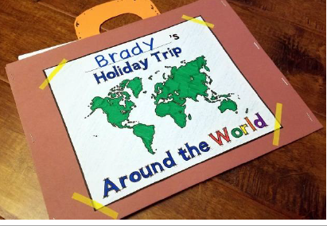 | Little Social Studies Thinkers Unit 3: Holidays Around The World Lesson 2  * Students will listen to the teacher read Los Posadas by Karen Jones (display on Active Board)  * Students will look at a map of Mexico on Google Earth.  * Students will chose a poinsettia “leaf” to answer questions about Los Posadas  * Students will read the sentences and fill in the missing letters about Los Posadas  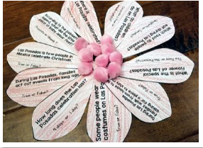 | * Introduce the term “recycle” and ask for student responses regarding their own understanding of recycling.  * Review the story “The Three Little Pigs” and ask students if they noticed any examples of recycling. *Introduce the idea of “reuse”. Explain that when we recycle, it doesn’t mean we necessarily turn something old into something different and new, but that we can also just “reuse” something  * Students will discuss with a partner if this ended up being a wise “reuse” decision for the pigs and if there might be better materials to reuse to build a home for pigs.  * Students will draw and label a home made out of reused/recycled materials, using the “My Recycled Home” drawing sheet  Students can include materials that are not recyclable. In later discussions the class will determine what can be recycled and what can’t and there will be room for a discussion about what would happen to their house if they use materials that cannot be recycled. | * Students will examine recyclable materials brought from home (make sure they have the recycle symbol on them).  * Students will work in small groups of 3-5 to discuss the following questions:  What do you notice about your materials?  Could you turn any of them into something else? If so, what?  * Students will generate a group list of what they could turn their materials into. (Use attached “What could it be? Worksheet”)  * Each group will share their materials and the list of ideas they came up with for recycling each material.  Homework: Have students bring in 1 recyclable item from home. (Send home the included “Parent Letter” to inform parents of the assignment and to direct them on what types of things to send in with their child.) | Introduce lesson with a recycling read aloud (A list of recycling books is provided below)  * Show the “Reduce, Reuse, Recycle” Brain Pop Jr video  * Students will bring 1 of the recyclable materials from home to the carpet to be sorted into groups:  paper, plastic, glass and metal.  * Students will place the recyclable materials into the labeled bins, including a “trash” pile for students who bring in non-recyclable materials.  Ollie’s World (Online Recycling Games for kids): http://www.olliesworld.com/  Suggested books about recycling:  Litterbug Doug By: Ellie Bethel  Michael Recycle By: Ellie Bethel  My Big Green Teacher By: Michelle Glennon  The Garbage Monster By: Joni Sensel  Recycle! A Handbook for Kids By: Gail Gibbons  The Adventure of a Plastic Bottle By: Alison Inches  The 3 R’s: Reuse, Reduce, Recycle By: Nuria Roca  Why should I recycle? By: Jen Green  Reusing and Recycling By: Charlotte Guillain

