Force and Motion Little Science Thinkers Unit 6
Kindergarten
April 15-19, 2019
Standards:  K-PS2-1: Plan and conduct and investigation to compare the effects of different strengths or different direction of pushes and pulls on the motion of an object  K-PS2-2: Analyze the data to determine if a design solution works as intended to change the speed or direction of an object with a push or a pull. |  |  |  | Focus Skills:  * Investigate how force and gravity affect the motion of an object.  * Investigate how a marble moves using different ramps.
Materials Needed for Marble and Ramp Experiment: Marble, pool noodle (12” section cut into 2 semi circle ramps), wooden blocks, piece of felt or rug, paper cups, tape measure, Marble and Ramp Experiment Booklet. |  |  |  |  |  | 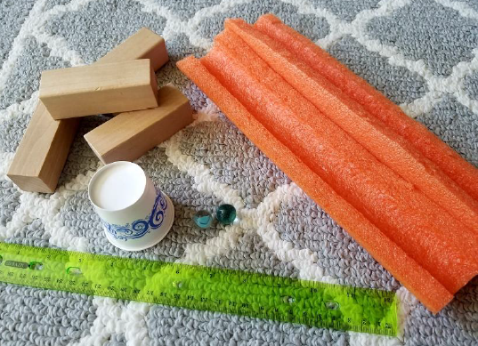
 | Monday (4.15) | Tuesday (4.16) | Wednesday (4.17) |  | Thursday (4.18) |  | Friday (4.19)
Learning Target | We can explain how gravity affects motion. | We can conduct an experiment to learn how a marble moves using different ramps. | BARN HILL PRESERVE FIELD TRIP |  | SPRING CONCERT  MOH FAMILY PICNIC DAY |  | GOOD FRIDAY  SPRING BREAK  NO SCHOOL
Science | Force and Motion Lesson 5:  * Introduce the learning target, display the guiding question: “What is gravity? What are some examples of gravty?” on chart paper and ask students to share their ideas.  * Read and discuss Gravity (Display PP on Activeboard)  * Revisit guiding question and record student responses.  Investigation:  * Students will investigate the properties of objects affect the way they move.(color, size, shape, weight, and texture) and record their results on a recording sheet.  *Students will share their results with the class and the teacher will record the results on an anchor chart.  * Students will complete Activity Page 6.5 | Force and Motion Lesson 6:  * Revisit previous achor chart about what scientists do:  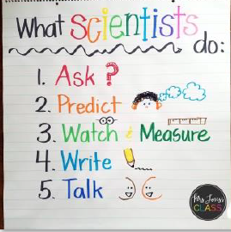  Marbles and Ramps Experiment:  * Students will use the materials listed above to see how different ramps affect eh force and motion of the marble.  * Students will make predictions about how the marble moves and record their predictions in their experiment booklet.  * Students will record their results as they move the marble on high and low ramps in their experiment booklet.  This activity can be done on small groups or as a whole class,. Students will need guidance from the teacher to set up the ramps before moving the marbles.  * Students will complete Activity Page 6.6

