Force and Motion Little Science Thinkers Unit 6
Kindergarten
April 29-May 3, 2019
Standards:  K-PS2-1: Plan and conduct and investigation to compare the effects of different strengths or different direction of pushes and pulls on the motion of an object  K-PS2-2: Analyze the data to determine if a design solution works as intended to change the speed or direction of an object with a push or a pull. |  |  |  | Focus Skills:  * Investigate how force and gravity affect the motion of an object.  * Investigate how a marble moves using different ramps.  * Investigate how simple machines work.
Materials Needed for Marble and Ramp Experiment: Marble, pool noodle (12” section cut into 2 semi circle ramps), wooden blocks, piece of felt or rug, paper cups, tape measure, Marble and Ramp Experiment Booklet. |  |  |  |  |  | 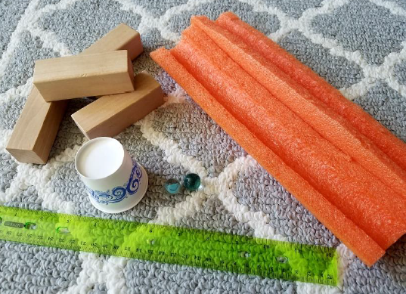
 | Monday (4.29) | Tuesday (4.30) | Wednesday (5.1) |  | Thursday (5.2) |  | Friday (5.3)
Learning Target | We can explain how gravity affects motion. | We can conduct an experiment to learn how a marble moves using different ramps. | We can explain what a simple machine is. |  | We can investigate Simple Machines  Simple Machines Stations Materials needed:  > Lever: pink erasers and popsicle sticks to create a lever and fulcrum; assorted small objects of different sizes, shapes, and weights.  *Students will use their own lever and fulcrum to lift different objects.  >Wheel and Axle: buttons, pipe cleaners, straws cut into 1/4ths., construction paper, cotton balls, tape scissors.  * Students will use their materials to build a car to carry a cotton ball.  > Wedge: plastic trays, playdoh, plastic knives, unsharpened pencils, paper and cardboard cut into wedge shapes, small garden shovel, push pins, nails  * Students will use various tools to cut playdoh  >Pulley: 2 chairs turned back to back and a broomstick; tape a plastic baggie to the end of a long string of yarn and use objects of different sizes and weights.  * Students will use the pulley system to lift objects of different weights and sizes.  >Incline Plane: hard cover books, blocks, rulers, long pieces of yarn, objects of different sizes and weights.  * Students will create an incline plane using yarn to pull objects on the incline plane.  > Screw: jars and bottles of different sizes and shapes, pompoms, nuts and bolts  * Students will investigate when a screw is properly fastened and when it is not.  *Students will record their findings in their Simple machines Stations Booklet.  Students will complete 3 stations each day.
Science | Force and Motion Lesson 5:  * Introduce the learning target, display the guiding question: “What is gravity? What are some examples of gravity?” on chart paper and ask students to share their ideas.  * Read and discuss Gravity (Display PP on Activeboard)  * Revisit guiding question and record student responses.  Investigation:  * Students will investigate the properties of objects affect the way they move.(color, size, shape, weight, and texture) and record their results on a recording sheet.  *Students will share their results with the class and the teacher will record the results on an anchor chart.  * Students will complete Activity Page 6.5 | Force and Motion Lesson 6:  * Revisit previous anchor chart about what scientists do:  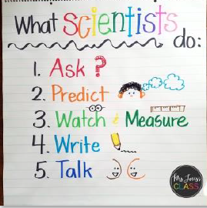  Marbles and Ramps Experiment:  * Students will use the materials listed above to see how different ramps affect eh force and motion of the marble.  * Students will make predictions about how the marble moves and record their predictions in their experiment booklet.  * Students will record their results as they move the marble on high and low ramps in their experiment booklet.  This activity can be done on small groups or as a whole class,. Students will need guidance from the teacher to set up the ramps before moving the marbles.  * Students will complete Activity Page 6.6 | Force and Motion Lesson 7:  Introduce the learning target and display the guiding questions: “What is a simple Machine?” and “How do we use simple machines?” on chart paper.  *Read and discuss Simple Machines (display PP on Activeboard)  * Revisit guiding questions and record student responses.  *Students will help to create an anchor chart using pictures of different simple machines.  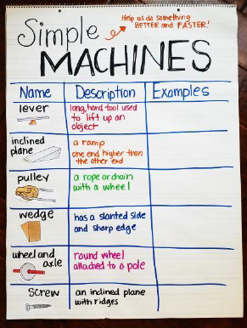  *Students will use pictures from the PP displayed on the ActiveBoard to determine the type of simple machine each object is.  *Students will complete Activity page 6.7

